**Analysing change drivers and scenario planning**

We can understand organisations as open systems, that is to say, a network of systems that are not closed off from the outside environment. The systems that constitute an organisation can be regarded as:

* Economic systems
* Technological systems
* Process systems
* Cultural systems

As an open system, the organisation is not, or rather cannot be considered as, a system that is insulated from the impact of change drivers from the broader macro environment. Change drivers are any external or even internal force which creates change in an aspect of the organisation’s system. These changes may be minor, or they may be hugely significant. They may be framed as operational continuous improvements ensuring some degree of alignment with the external environment, or they may be framed as discontinues strategic shifts in the nature and form of operations.

The impact of change drivers could be immediate. For example, changes in tax levels, or they may be longer-term such as shifting demographics and consumer tastes. Often change managers/leaders will be called upon to analyse the nature of the change drivers that the organisation should pay attention to, and to create with the leadership plausible scenarios of the future trading situation an organisation will be faced with as a result of how they respond to and address key change drivers.

The main tool we can use to manage the analysis of the external environment regarding change drivers is a PESTEL Analysis which can be used, for example, over a five-year timeline to identify the main change drivers that will shape an organisation’s competitive position going forward.

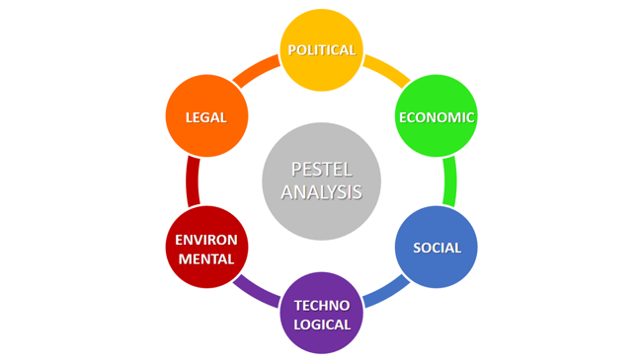

PESTEL involves conducting an analysis of the change drivers in the external environment of an organisation which can affect its activities and performance. PESTEL analysis is a simple and effective tool used in situation analysis to identify the key external (macro environment level) forces that might affect an organisation. These forces can create both opportunities and threats to an organisation. Therefore, the aim of applying PESTEL is to:

* Find out the current external factors affecting an organisation.
* Identify the external factors that may change in the future.
* Exploit the changes (opportunities) or defend against them (threats)

The outcome of PESTEL is an understanding of the overall change picture surrounding the organisation. Conducting a PESTEL is a very enjoyable and creative activity which is greatly enhanced when managers incorporate the cultural dimensions of strategic planning and change management into their analytical model. PESTEL illustrates the macro-environment forces affecting a firm.

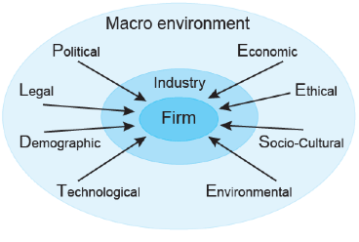

Change drivers are also fundamental aspects of strategy development, as they influence the likelihood of success and failure in an organisation. For example, the current environmental crises that are driving change in our supply chains, in almost every industry on earth, could have been managed and even avoided if the world’s business leaders had seriously engaged with an environmental analysis using PESTEL to work out the pressure on the environment caused by C02 emissions and the excessive use of plastics. They could have painted very plausible scenarios of how society would react to the damage that will be done to the natural systems and the wave of united pressure from stakeholder groups to change their production and service delivery systems to become world leaders as eco- friendly business practices. Some did, and sadly, many did not and are now playing catch up to the detriment of the broader natural and social environment. The following example is a PESTEL analysis of an organisation thinking about investing in a new country as an emerging market.

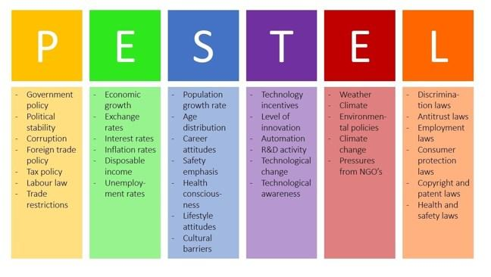

The change manager would arrange for a representative group of managers and staff to meet for a PESTEL process mapping focus group session. They would brief the team on the principles of PESTEL analysis, what it is, how it works, and invite them to collaboratively brainstorm as many change drivers as they can, that they feel relate to each PESTEL element. The groups would write down their own ideas regarding change drivers for each PESTEL category and then compare these and remove duplication. They would then discuss each one, agree as a group that it represents a significant change driver, and then simply post the change drivers under each element of PESTEL on a dedicated flip chart sheet. Once this exercise has been exhausted the session ends and the change manager would compose a record of the PESTEL analysis and its content for the next strategic change session, which would involve scenario planning.

**Key Lessons**

Adopting systematic analytical tools such as PESTEL enables the change manager to work as a team facilitator and lead management through workshops to help them make sense of the ever-changing environment, and to foresee the nature of specific change drivers, and appreciate their inevitable impact on the organisation and its operations. The organisation is best considered as an open system and one that interacts with cultural, economic, process, and technological systems. This awareness opens avenues for the change manager such as mapping change, and systems thinking which are rich and resourceful change tools and perspectives. PESTEL Analysis is also an effective way to build connections between the present and the future, and when blended with scenario planning and stakeholder mapping its utility as a change management tool is enhanced even more. We shall explore this in the next article.